# Staff Report

Meeting Date: April 15, 2025

To: Siskiyou County Board of Supervisors

From: Hailey Lang, Planning Director

Subject: JH Ranch Planned Development Amendment

## Background

*Prior Approvals*

In 1970, JD Proctor filed a Use Permit application (UP-70-22) to establish the original JH Ranch which consisted of a trailer park with 14 spaces. On August 1, 1973, UP-73-55 was then approved to allow for up to 136 people on site at any given time. In 1979, the Rolland Gene Johnston family purchased JH Ranch from JD Proctor. In 1982, Mr. Johnston applied for a Use Permit to construct five (5) duplex buildings in conjunction with the guest ranch. The Use Permit was approved on November 19, 1982 (UP-82-37)

1989, Mr. Johnston submitted a PD rezoning application (Z-89-15) and Use Permit application (UP-89- 05) requesting approval to increase the summer recreational occupancy from the approved 136 occupancy level to a 250-occupancy level and to establish an educational facility for up to 96 students during the non-summer guest ranch usage periods of September through May. The applications were ultimately withdrawn.

The first zone change was approved by the Board of supervisors on July 28, 1981, which designated 6.48 acres to the C-1 zoning district as delineated on sectional district amendment map 10-6.205-422-7.

The first Planned Development District (P-D) for JH Ranch was approved in 1982 applied exclusively to land in T41N, R9W, Sections 29 and 32 (MDB&M), approximately 79 acres. The establishment of the PD district allowed for the construction of five duplex cabins as well as a zone change from Rural Residential (RR) to Planned Development (PD) under Siskiyou County Ordinance 82-1090.

Amendment #1 fixed a zoning error, changing the zoning classification from C-1 to Neighborhood Commercial (C-R) under Siskiyou County Ordinance 89-05.

Amendment #2 authorized the inclusion of 17 existing cabins, a laundry room, and a barn, under Siskiyou County Ordinance 93-41. This entitlement application was processed under a Class 1 CEQA exemption pursuant to Section 15301 (a Class 1 exemption involves negligible or no expansion of use). At that time, the application was thought of as a status quo application seeking approval for the then current activities.

Amendment #3, the presently proposed amendment, intends to bring the current uses of the property into full compliance with what is currently occurring at the Ranch, including a historic occupancy of 505 persons.

*Existing Conditions*

JH Ranch (“the Ranch”) is an approximately 165-acre property with Planned Development (PD), Neighborhood Commercial (C-R), and Rural Residential Agriculture (R-R) zoning districts associated with APN 023-190-510. The Ranch is operating under the 1993 approval (Amendment #2). The uses and structures currently occurring on the property are identified on the Site Plan as well as the revised Planned Development Master Plan (PDMP).

*Proposed Project Summary*

The proposed project seeks to establish a maximum occupancy of 505 persons at the Ranch, as well as bring the property into full compliance. The maximum occupancy includes all individuals on the property at any given time. No expansion of occupancy, uses, or structures are proposed as part of this project.

This project also includes a revocation of the previous use permits to consolidate all the approved uses into a single use permit. Conditions of approval that are no longer necessary, have been complied with, or would be satisfied/fulfilled with new conditions of approval may be eliminated. Should the proposed zone change (Z-23-06) and/or use permit (UP-24-15) not be approved, the existing use permit approvals would continue to be effective.

Section 10-6.1186 requires that any changes to a PD must be treated as changes to the zoning. This Zone Change proposal is to update the JH Ranch Master Plan to reflect current activities and uses and to remove the facilities and uses no longer planned or proposed as development plans have changed. An amendment master plan can be found in Exhibit A-3. The PD amendment includes the following updates:

• Inclusion of the current uses and structures located at the Ranch

• Inclusion of JH Ranch operation

• Removal of inconsistent language

• Removal of facilities and uses no longer planned or proposed within the Ranch

• Formatting updates as needed

Section 10-61183 outlines that a Use Permit (UP) is required for any and all uses within a multi-phase or multi-use P-D district. Considering that the JH Ranch property has multiple zoning districts, uses, and programs that occur onsite, Section 10-61183 applies.

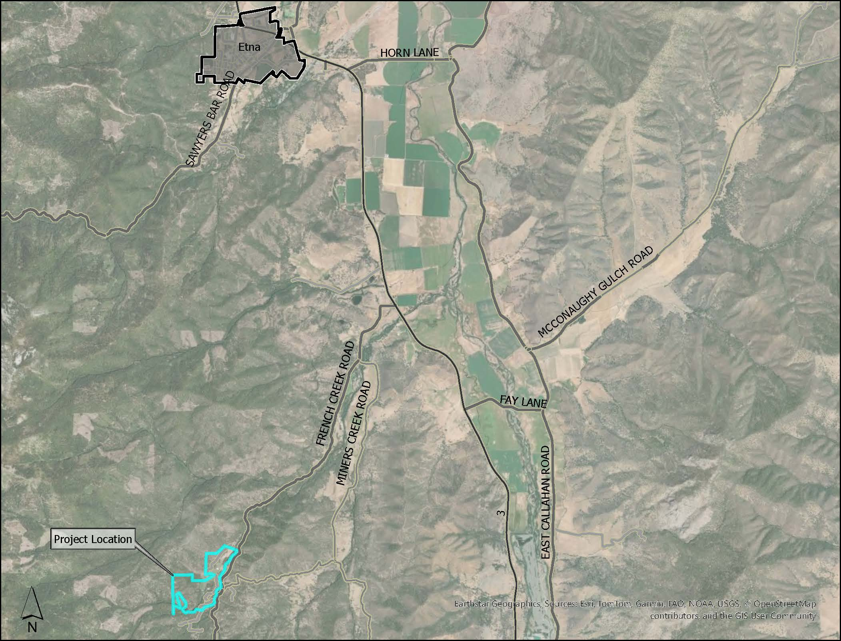  
**Figure 1: Project Location**

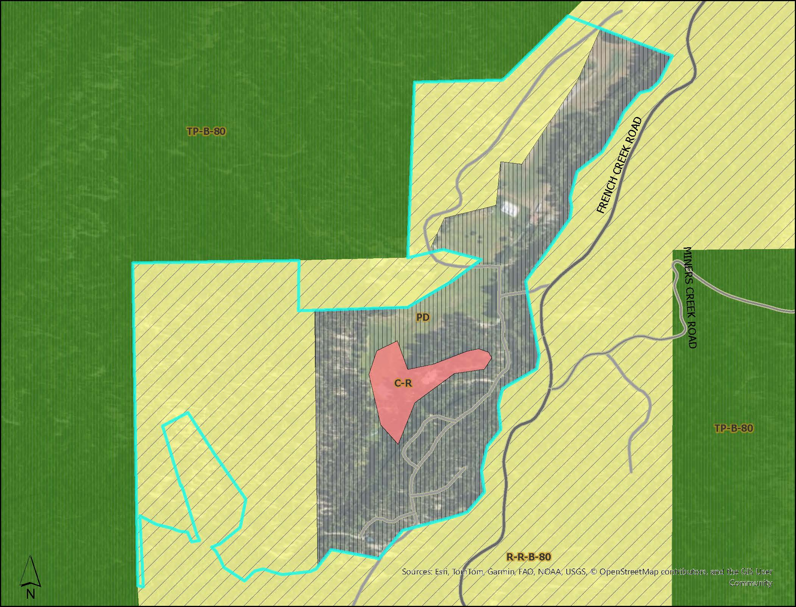  
**Figure 2: Zoning Map**

## Analysis

*General Plan and Scott Valley Area Plan (SVAP) Consistency*

The Land Use Element of the Siskiyou County General Plan identifies the project site as being within the mapped resource overlay area for Soils: Erosion Hazard; Soils: Building Foundation Limitations; Excessive Slope; Flood Hazard; Critical Deer Wintering Area; Wildfire Hazard; Woodland Productivity. Planning staff have identified that Composite Overall Policies 41.3(b), 41.3(e), 41.3(f), 41.5, 41.6, 41.7, 41.8, 41.9, 41.10, 41.12, 41.13, 41.15, 41.18, and 41.19(b) apply to the proposed project.

The proposed project falls under the following land use designations of the SVAP: Excessive Slope, Critical Deer Wintering, Flood Plain, and Non-Resource Area Policies. The project would not conflict with applicable plans that have jurisdiction over the project area. Consistent with the applicable County land use and Scott Valley Area Plan policies, the project is an organized camp, compatible with adjacent land uses.

Staff have conducted a detailed analysis of each of the required findings and found that the proposed project is consistent with the applicable General Plan policies governing the subject site. Additionally, the use of the property, is compatible with the surrounding land uses, would have adequate roadway access for transportation and public health and safety provisions, and would not create significant environmental impacts to on- or off-site resources. The recommended findings are detailed in the General Plan Consistency Findings section of Exhibit A-2 attached to this staff report and are submitted for the Commission’s review, consideration, and approval.

*Zoning Consistency*

Pursuant to Siskiyou County Code Article 11-D. Planning Development Districts (P-D), the proposed project meets the requirements of the PD zoning. Since the PD is a multi-use development, a Use Permit is also required for the proposed project.

The Planned Development District is designated to accommodate various types of development or any other use or combination of uses which can be made appropriately a part of a planned development.

The P-D District is intended to enable and encourage flexibility of design and development of land in such a manner as to promote its most appropriate use; to allow diversification in the relationship of various uses, structures, and spaces; to facilitate the adequate and economical provisions of roads and utilities; and to preserve the natural and scenic qualities of open space and offer recreational opportunities close to home.

The regulation outlined in Section 10-61183(c), outlines that a Use Permit shall be required for any and all uses within a multi-phase or multi-use (more than one) P-D District. Additionally, the amendment to the PD allows for an up-to-date Master Plan document, which reflects the current uses, structures, programs, and operations that occur onsite. Based on staff’s analysis of the proposed use, staff believes that the necessary findings can be made for the approval of this application.

## Discussion

The amendment to the Planned Development Master Plan is necessary to account for the current uses, structures, programs, and operations of the Ranch. Additionally, since the Ranch is a multi-use ongoing development, a Use Permit is required to account for the variety of uses that occur on the property. The below uses and facilities, are the primary changes that have been included in the PD Master Plan, as part of this amendment:

* Accurate project description: an updated and accurate project description has been written to account for what is currently occurring on site.
* Development objectives: objectives of the PD Master Plan have been added to help guide development of the Ranch.
* Approved uses and structures: an updated list and description of all uses and structures that are on site.
* Operational information: language regarding programs and operations of JH Ranch have been added.
* Emergency Evacuation Plan: an updated and approved emergency evacuation plan has been added as an appendix to the PD Master Plan.
* Compliance Review Procedures: consistent with previously approved PD Master Plans (and amendments), the compliance review process has been added to this amendment.
* Site Plan: an updated site plan which reflects what is currently on site has been added.

## Comments

A Notice of Public Hearing was published in the Siskiyou Daily News on March 5, 2025, and mailed to property owners within 300 feet of the applicant’s property. Four public comments have been submitted in opposition to the project.

## Environmental Review

Pursuant to CEQA Guidelines Section 15125 Environmental Setting, the lead agency must determine whether the proposed project creates an effect on the environment. Generally, the lead agency should describe physical environmental conditions as they currently exist. Environmental Setting can be described as the ‘baseline’ for what is currently occurring and shall not include hypothetical conditions.

Baseline considers existing uses (both authorized and unauthorized) because uses provide evidence of long-term continuous existing conditions. CEQA is not to be used as enforcement for violation of laws or entitlements.

As the proposed project is simply bringing the current property into compliance and there is no increase and/or expansion of occupancy, uses, structures, or programs, the project falls under the Class 1 (Existing Facilities) exemption. The Class 1 exemption consists of the “operation, repair, maintenance, permitting, leasing, licensing, or minor alteration of existing public or private structures, facilities, mechanical equipment, or topographical features, involving negligible or no expansion of existing or former use”. With there being no increase and/or expansion of occupancy, structures, or uses, the proposed project is able to utilize the Class 1 exemption.

## Recommended Action

Adopt Resolution 2025-0XX.

## Recommended Motion

I move to take the following actions:

1. Introduce, waive the second reading of, and adopt an ordinance amending the Planned Development of APN 023-190-510; and;
2. Approve a resolution approving the JH Ranch Use Permit (24-16) and the project’s categorical exemption.

## Attachments

1. Resolution 2025-0XX.
2. Conditions of Approval UP-24-16
3. Findings
4. Draft Ordinance
5. Zoning Ordinance Map
6. Planned Development Master Plan
7. Site Plan
8. Fire Emergency Plan
9. Staff Report Package for February 19, 2025, Planning Commission Hearing
10. Comments as of April 1, 2025